English tenses.

Every english Verbs form has two parts:

time: past present future

aspect: simple, continuos (progressive), perfect, perfect continuos

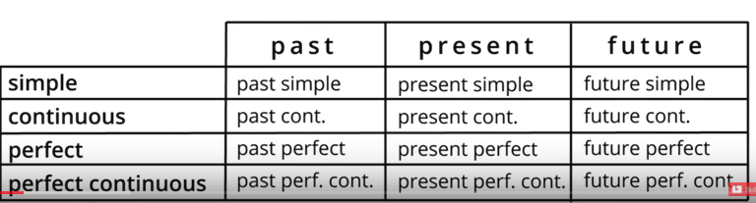

PAST CONTINUOS: I was having dinner this time yesterday. (time past and aspect continuos)

PRESENT PERFECT CONTINUOS: He’s been sitting there for hours. (time present and aspect perfect continuos)

FUTURE SIMPLE: Where will you be next week? (time future and aspect simple)

PRESENT SIMPLE: I go shopping once a week.

PAST SIMPLE: I went shopping once a week.

…just use the past or present form of verb….

I’ll be waiting for you outside the station

When are you going to tell her?

He might join us later.